Customer Shopping Analysis Report (2021–2023)

Name: Yogyata Sahu
Batch: 19th January (CDA)
Institute: DataMites

Project Objective
The objective of this project is to analyze customer shopping behavior based on gender, age group, product category, and payment method. The analysis aims to identify customer trends, purchasing patterns, and potential business opportunities that can support data-driven decision-making.

Objectives

Analyze shopping distribution by gender.

Analyze shopping distribution by age category.

Study revenue generation patterns.

Understand payment method usage.

Identify customer purchasing behavior.

Generate business recommendations.

Dataset Description
The dataset contains shopping information collected from 10 shopping malls between 2021 and 2023. It includes customer demographics, purchased product categories, quantity, price, payment methods, and shopping mall details.

Dataset Attributes
- Invoice Number
- Customer ID
- Gender
- Age
- Category
- Quantity
- Price
- Payment Method
- Invoice Date
- Shopping Mall

Tools Used
SQL
- Data Cleaning
- Data Transformation
- Customer Segmentation Analysis
- Revenue Analysis
- Demographic Analysis
SQL Analysis Performed
The dataset was analyzed using SQL to identify customer purchasing behavior and revenue trends. The following analyses were conducted:
- Gender-wise shopping distribution and revenue analysis.
- Age-group-based customer segmentation.
- Product category performance analysis.
- Payment method preference analysis.
- Revenue generation by category and payment method.
- Shopping mall-wise transaction analysis.
- Cross-analysis of gender, age group, category, and payment methods.
- Average customer spending analysis by age group.
The results of these analyses were used to create interactive Power BI dashboards

Power BI
- Dashboard Development
- Data Visualization

WPS Office
- Report Preparation and Documentation
Power point
PPT preparation

Data Cleaning
The following data-cleaning steps were performed:
- Removed null values
- Verified and corrected data types.
- Created a Revenue column using:
Revenue = Quantity × Price
- Checked and removed duplicate records.
- Standardized column names for consistency.

Dashboard Analysis

Customer Shopping Analysis Report (2021–2023)
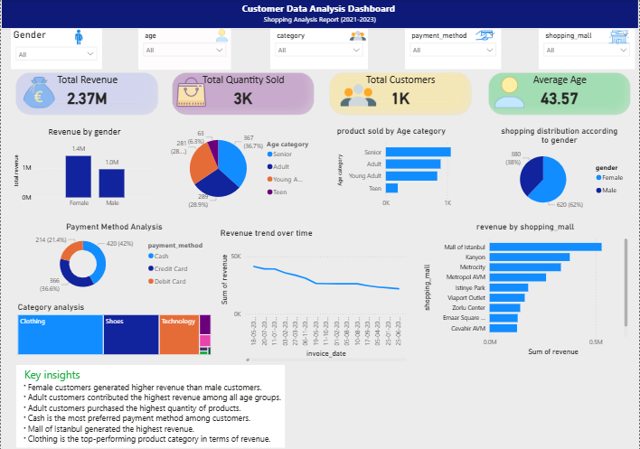

1. Shopping Distribution by Gender
Insight:
Female customers contributed a larger share of total purchases compared to male customers.
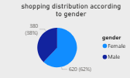
SQL query
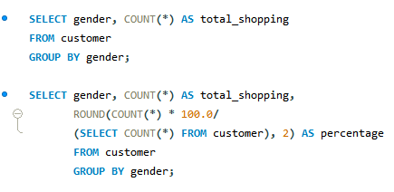

2. Revenue by Gender
Insight:
Female customers generated higher revenue, indicating stronger purchasing activity and spending behavior.
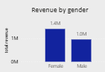
SQL query
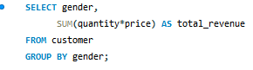

Revenue by age
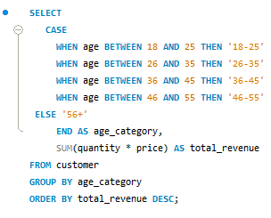

3. Shopping Distribution by Age Category
Insight:
Customers aged 26–35 years showed the highest shopping frequency among all age groups.
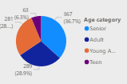
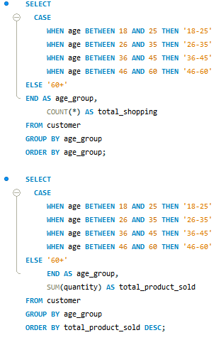

4. Category Analysis
Insight:
Clothing and Shoes categories recorded the highest sales and customer demand.
Revenue by Category
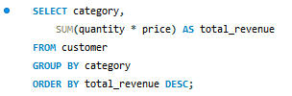
Category Purchases by Gender
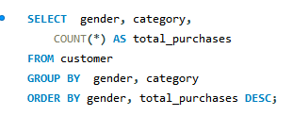
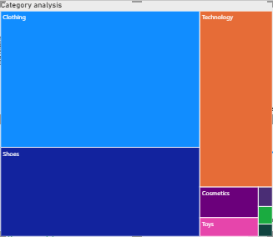

Payment Method Analysis

Insight:
Credit Card was the most preferred payment method among customers. 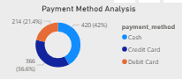

Transactions by Payment Method and Revenue by Payment Method
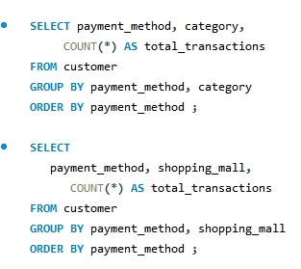

Shopping Mall Analysis

Category vs Shopping Mall
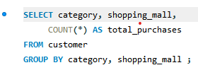

Payment Method vs Shopping Mall



Customer Segmentation

Age Group vs Category
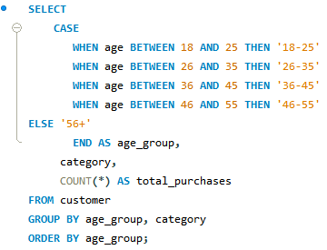

SQL Queries Used

- Gender Revenue Analysis
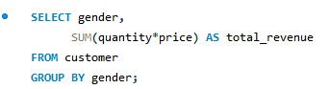

- Category Revenue Analysis

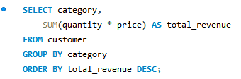

- Payment Method Revenue Analysis
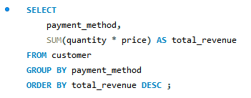

Average Spend Analysis



Key Findings

Female customers purchased more products than male customers.

Female customers contributed 58% of total revenue, while male customers contributed 42%.

Customers aged 26–35 years were the most active shoppers.

Clothing was the highest-selling product category.

Credit Card was the most commonly used payment method.

Shopping trends indicate strong purchasing behavior among young and middle-aged customers.

Recommendations
Based on the analysis, the following recommendations are proposed:

1. Target Female Customers
Develop personalized marketing campaigns, exclusive promotions, and loyalty benefits to increase engagement and retention.

2. Introduce Loyalty Programs
Focus on customers aged 26–45 years to encourage repeat purchases and strengthen customer loyalty.

3. Promote High-Performing Categories
Increase inventory levels and marketing efforts for Clothing and Shoes to maximize revenue opportunities.

4. Encourage Digital Payments
Offer discounts, cashback rewards, and special incentives on card transactions to boost digital payment adoption.

5. Implement Cross-Selling Strategies
Recommend complementary products to customers to increase average order value and overall sales.

6. Customer Segmentation
Design targeted marketing campaigns based on customer age groups, shopping behavior, and product preferences.

Conclusion
The analysis identified important customer purchasing patterns based on gender, age, product category, and payment method. Female customers and the 26–35 age group emerged as the most significant contributors to sales and revenue. Clothing and Shoes were the top-performing categories, while Credit Card remained the preferred payment method.
These insights can help businesses improve marketing strategies, enhance customer engagement, optimize product offerings, and increase overall revenue generation.

Thank you

